Quantitative Module C

Transportation Models

**Background**

The transportation model is one of the classic linear programming models. It provides the basis for more complex models such as the transshipment model (which includes intermediate distribution centers between the plants and the final destinations) and location-allocation models (where part of the decision is where to open plants and the other part is how much to make at each plant and where to ship the output).

The transportation model has a special structure that allows it to be solved by hand. In fact, the examples in this module go straight from the data to the transportation matrix, without needing to provide the actual linear programming formulation. When solving these problems by hand, students need to always be aware of the two potential special cases and how to handle them: (1) unequal supply and demand, and (2) degeneracy. Instructors should also note that computer software can solve the transportation problem, including Excel OM and POM for Windows that have pre-defined modules for that task.

**Class Discussion Ideas**

1. After presenting the basic structure of the transportation model to the class, ask the students what real-world factors or considerations (constraints) might be missing. Examples might include: (1) required minimum production levels at each plant, (2) fixed as opposed to variable transportation costs, (3) a profit situation where demand is represented as potential demand that does not necessarily have to be satisfied, (4) pre-contracted amounts between sources and destinations, and (5) prohibited shipments. Prohibited shipments can be accommodated by using a coefficient of infinity, but the existence of some of these other conditions would preclude the use of the stepping-stone method. A linear program could still be formulated with these constraints included, but it would have to be solved on a computer.

**Active Classroom Learning Exercises**

1. Divide the class into groups. Have each group identify a multi-site organization that could use the transportation method to help them solve resource allocation problems. The students should identify the sources and demand locations (make sure that they limit these to something like five sources and five destinations). Because the students are not likely to have actual supply and demand figures, or the relevant costs, have them create reasonable estimates of these values and develop a transportation matrix for the organization. Have them solve the problem using the stepping-stone method.

**Presentation Slides**

INTRODUCTION (C-1 through C-3)

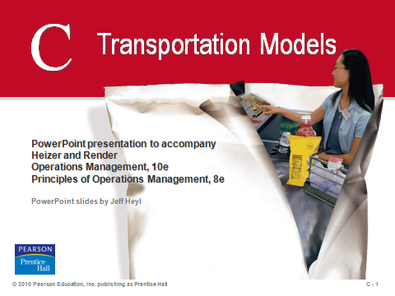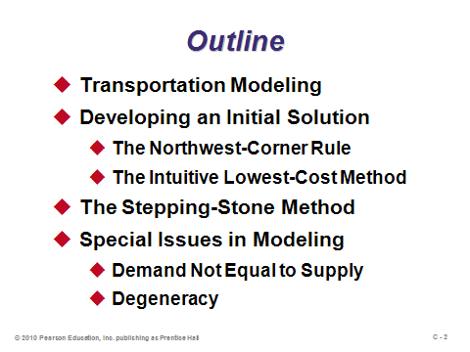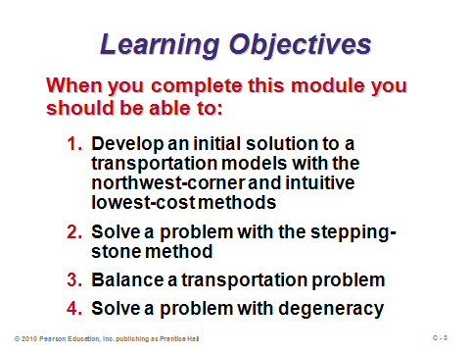

**C-1 C-2 C-3**

TRANSPORTATION MODELING (C-4 through C-8)

Slides 4-8: The transportation model is also known as type of *allocation* model, because units are being allocated to various destination points. Slide 5 identifies the data necessary to solve the problem. Slides 6-8 (Table C.1, Figure C.1, and Figure C.2, respectively) set up an example problem with three origin points and three destinations. Slide 8 is called a *transportation matrix*. Its purpose is to summarize all relevant data and to keep track of algorithm components.

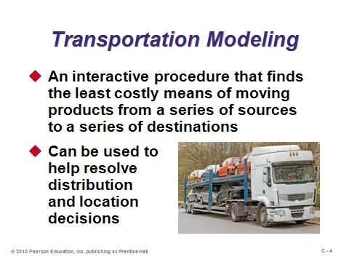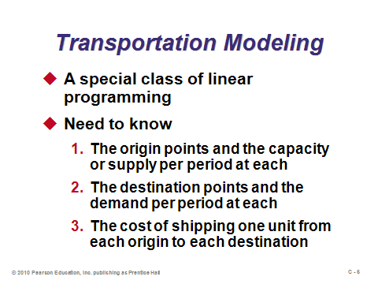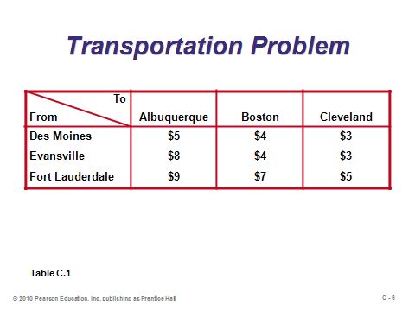

**C-4 C-5 C-6**

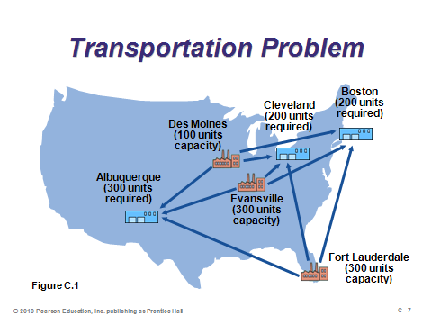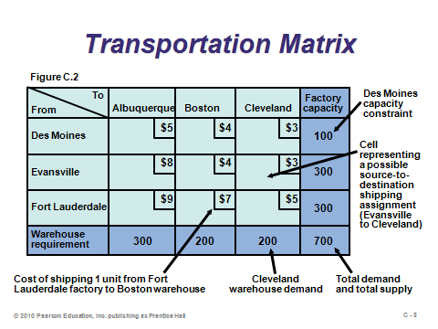

**C-7 C-8**

DEVELOPING AN INITIAL SOLUTION (C-9 through C-19)

Slides 9-12: These slides describe how to set up an initial solution using the *northwest-corner rule*. The steps are described in Slide 9, and the rule is applied to the example problem in Slides 10-12 (Example C1).

Slides 13-19: These slides describe how to set up an initial solution using the *intuitive lowest-cost approach*. The method makes intuitive sense (hence the name), and in most cases we would expect it to provide at least as good of a solution as the northwest-corner rule, which ignores costs. Slide 13 describes the steps. Slides 14-19 (Example C2) apply the rule to the example problem, step-by-step. For this example, the intuitive lowest-cost rule outperformed the northwest-corner rule by $100. If the intuitive lowest-cost method always moves from lower costs to higher costs, why doesn’t it produce the optimal solution every time? The reason is that it’s a myopic policy that creates opportunity costs and may prohibit better combinations of allocations. For example, it could be the case that destination *Y* has a slightly larger cost from plant *W* than destination *X* has. And suppose that *W*’s supply is exhausted when allocated to destination *X* using the intuitive lowest-cost method*.* A problem will occur if the cost to destination *Y* from all other plants is very high. It might have been better to ship from *W* to *Y* and ship to *X* from a different plant, as long as that shipping cost is not too high.

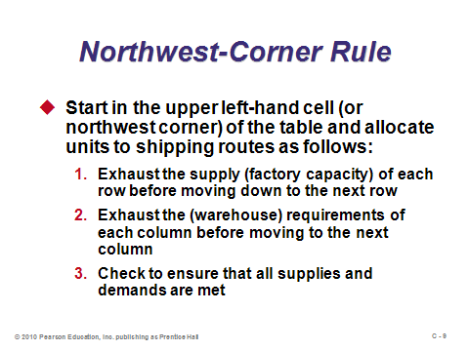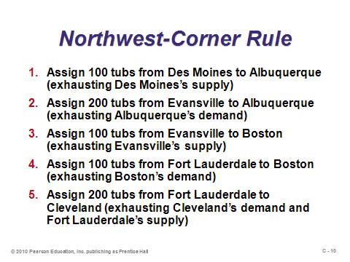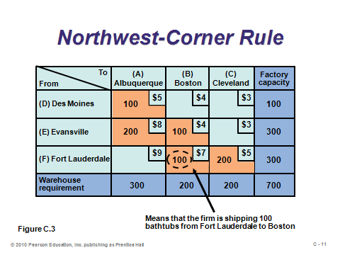

**C-9 C-10 C-11**

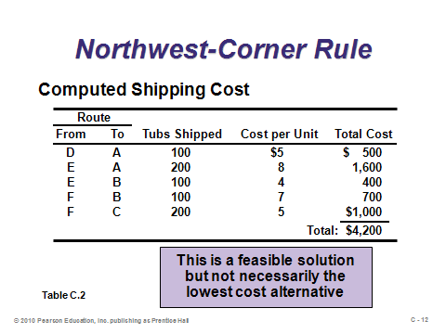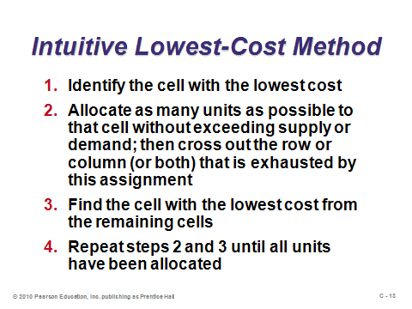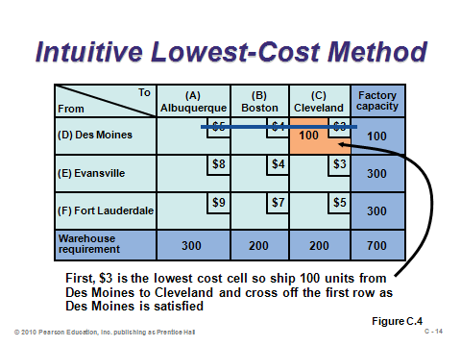

**C-12 C-13 C-14**

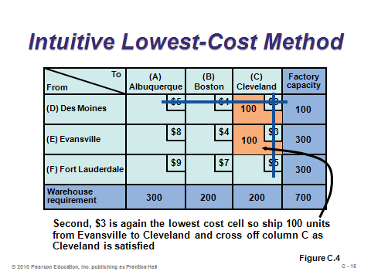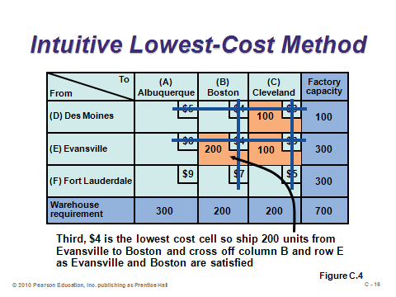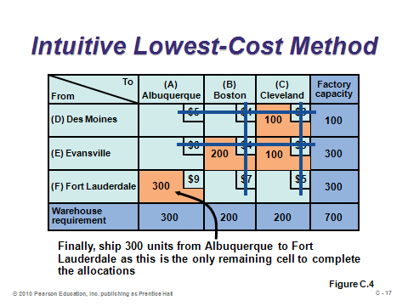

**C-15 C-16 C-17**

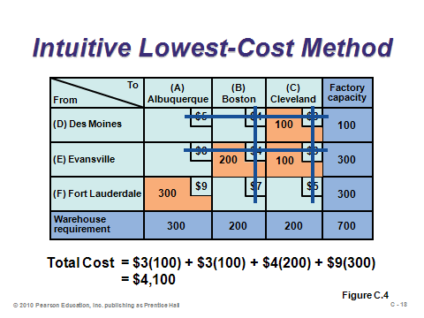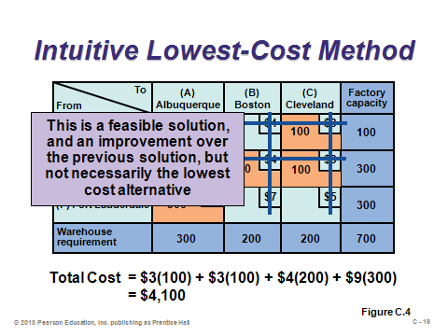

**C-18 C-19**

THE STEPPING-STONE METHOD (C-20 through C-27)

Slide 20-21: Beginning with any initial feasible solution, the *stepping-stone method* will find the optimal solution to the transportation problem. These slides provide the steps for testing if an improvement is possible. Steps 1 through 4 are repeated for all unused squares (there will be *rows × columns –* (*rows + columns – 1*) of them in a non-degenerate solution). Note that only one closed route exists for each empty square.

Slides 22-24: These slides (Example C3) apply the improvement step test to all four unused squares in the example problem. Since at least one path had a negative improvement index, the current solution is not optimal.

Slide 25: This slide presents the improvement steps of the stepping-stone method when at least one improvement index is negative.

Slides 26-27: These slides (Example C4) apply the improvement steps to the Fort Lauderdale-Albuquerque path of the example problem. The example stops here; however, this solution is not yet optimal. A repeat of the improvement test steps would show that more improvement is possible.

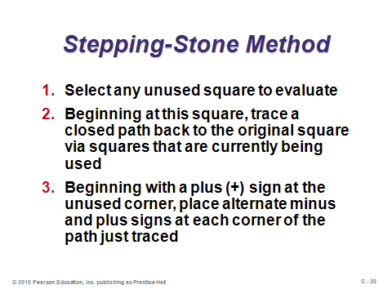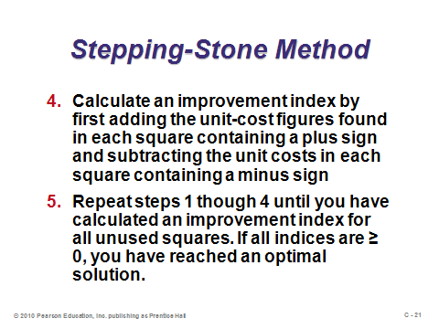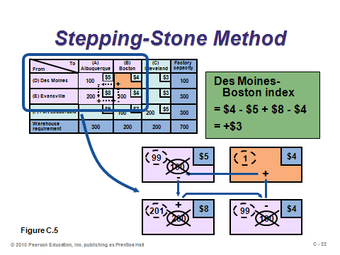

**C-20 C-21 C-22**

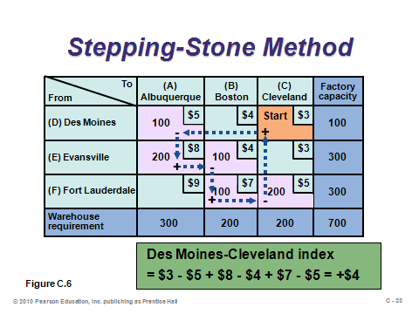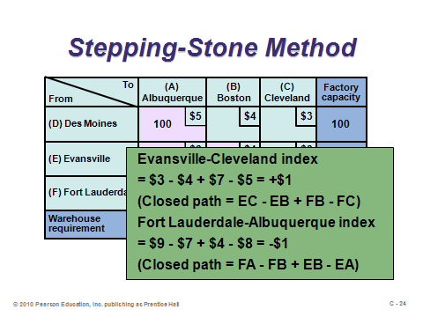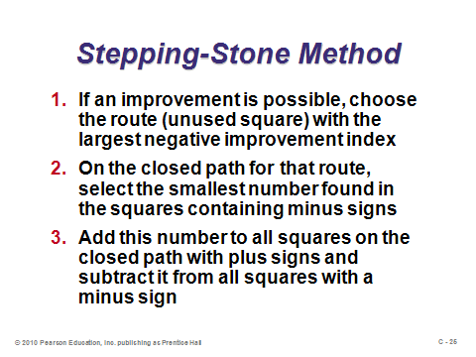

**C-23 C-24 C-25**

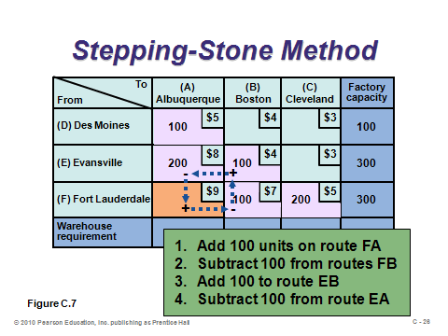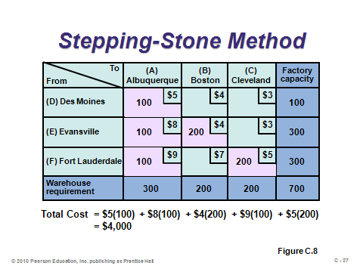

**C-26 C-27**

SPECIAL ISSUES IN MODELING (C-28 through C-31)

Slides 28-29: Total demand often does not equal total supply. In that case, either a dummy row or a dummy column should be added with a dummy capacity or demand, respectively, equal to the shortfall. All cost coefficients in the dummy row or column should equal 0. From there, the stepping-stone method can be applied. Any final allocation in the dummy row or column represents either unmet demand or unused supply, respectively. Slide 29 (Example C5) inserts a dummy column (destination) for the case of supply exceeding demand. Note that the 150 units that appear in that column exactly equal the amount of excess supply.

Slides 30-31: Slide 30 provides the definition of degeneracy. Before beginning the stepping-stone method, and after each new allocation, check to make sure that the solution is not degenerate. If it is, place a zero quantity in an unused square and proceed normally. Slide 31 shows how to do this (Example C6). The solution was degenerate because only four squares were occupied instead of the required (3 + 3 – 1) = 5.

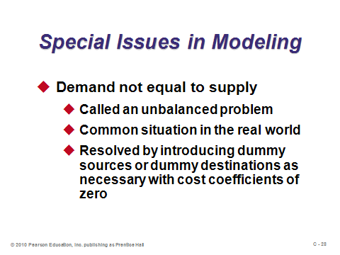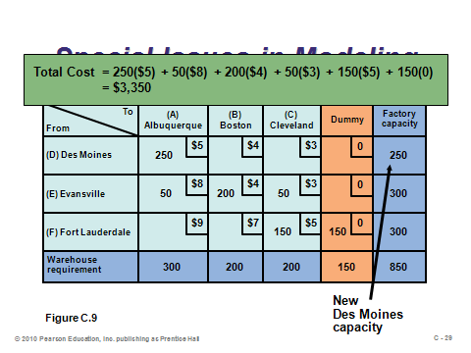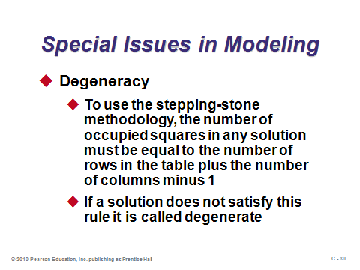

**C-28 C-29 C-30**

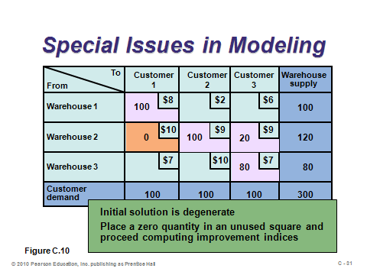

**C-31**

**Additional Assignment Ideas**

1. Visit a Web site of a transportation modeling software vendor and describe the features. Provide screen captures with your write-up.

**Additional Case Studies**

Internet Case Study (www.pearsonhighered.com/heizer)

* *Consolidated Bottling (B):* This case involves determining where to add bottling capacity.